**KNAPO WEB CONTENT**

**1. HOMEPAGE**

**MISSION STATEMENT:**

Our mission is to enhance professionalism in the area of crime prevention as well as non-custodial rehabilitation of offenders.

KNAPO aims to maintain professional standards in probation practice through a code of conduct, promote the welfare of its members, and act as an advisory body in policy development. It fosters cooperation among members, collaborates with global organizations, and provides a platform for research and discussions on probation practices. The association plans to mobilize resources to further its objectives.

**OBJECTIVES:**

Objectives of the association are to:

1. Ensure probation practice by maintenance of professional standards through a code of conduct.
2. Promote and protect the interests and welfare of its members.
3. Act as an advisory and consultative body in the planning, formulation and implementation of policies related to probation practice.
4. Foster fellowship and co-operation among members and liaise with other relevant organizations across the world in exchange of knowledge and experiences in pursuit of the objects of the Association.
5. Provide a platform where members can study, research, discuss and publish matters relating to probation practice.
6. Establish a KNAPO Research and Training Institute to enhance training and capacity building.
7. Form branches as approved by the General Assembly.
8. Mobilize resources and raise funds in furtherance of its objectives.
9. Invest monies of the association in such investments, securities or property as may be thought fit subject, but subject to such conditions as may, for the time being, be imposed.
10. Purchase, take on lease or in exchange, hire, or otherwise acquire any real or personal property and any rights or privileges necessary for the promotion of the said objects.
11. Sell, let, mortgage, and dispose off to the account of all or any of the property or assets of the association in furtherance of its objectives.
12. Undertake, execute and manage any charitable trusts which may lawfully be undertaken by the Association.
13. Initiate and participate in disciplinary matters relating to its members.
14. Do all such things as may be deemed incidental to the attainment of the above objectives.

**KEY MESSAGE:**

Joining the Kenya National Association of Probation Officers (KNAPO) offers key benefits, including professional development through specialized training, workshops, and certifications; access to conferences and the latest research; and a supportive community for personal and emotional well-being. Members also gain valuable networking opportunities with fellow professionals and organizations, as well as advocacy and representation for better working conditions and ethical guidance. Becoming a member strengthens your practice and contributes to the growth of the probation profession.

**LATEST NEWS/UPDATES:**

There are no announcements or events

**CONTACTS**

**Contact Information:**

The National Secretary,

Kenya National Association of Probation Officers,

P. O. Box 6104-00100,

Nairobi, KENYA.

Phone number: +254-702-850-673

Email: [knapo.org@gmail.com](mailto:knapo.org@gmail.com)

X : @KNAPO_

Facebook: knapokenya

**2. ABOUT US**

**OVERVIEW:**

The Kenya National Association of Probation Officers (KNAPO) is a professional body founded in 1976 by serving Probation Officers with the primary aim of addressing the issues of crime and deviance among both juveniles and adults. Since its establishment, KNAPO has grown significantly in membership and influence, making it a key organization for all practicing and retired Probation Officers in Kenya.

As a nonprofit organization, KNAPO operates with a clear code of ethics that governs the conduct and operations of its members. The association is dedicated to promoting the professional development, welfare, and advocacy of Probation Officers across the country. KNAPO has 11 branches across the Republic of Kenya, with its National Secretariat located in Nairobi.

The leadership of KNAPO is overseen by the National Executive Council (NEC), which is responsible for strategic decision-making. The National Executive Board (NEB), consisting of six key office bearers, guides the day-to-day activities and management of the association. Through its commitment to professionalism and service, KNAPO continues to play a vital role in the criminal justice sector in Kenya.

**VISION AND VALUES :**

KNAPO endeavours to enhance professionalism in the area of crime prevention as well as non-custodial rehabilitation of offenders.

Our core values are:

1. **Committed to professionalism and welfare:** Committed to promoting professionalism and welfare of members for social thrift and harmonious co-existence in the community,
2. **Embracing innovation:** Desirous to embrace, adopt and enhance novelle professional and welfare approaches in probation practice,
3. **Collaboration and cooperation:** Encouraging co-operation between Kenyan National Association of Probation Officers with local and international organizations to enhance probation best
4. **Advancement of justice and community corrections**: Believing such co-operation should advance professionalism and welfare of members to further the ends of justice and social reintegration.

**LEADERSHIP:**

**National Executive Board (NEB) Members:**

National Executive Council (NEC) Members

National Chairman – Wycliffe Wathome

Vice National Chairman – Veronica Irungu

National Secretary – Daniel Ng’etich

Vince National Secretary – Stephen Muthoka

National Treasurer – Edward Ochieng

Vice National Treasurer – John Soxwel Mokoro

**National Executive Council (NEC) Members:**

National Chairman – Wycliffe Wathome

Vice National Chairman – Veronica Irungu

National Secretary – Daniel Ng’etich

Vince National Secretary – Stephen Muthoka

National Treasurer – Edward Ochieng

Vice National Treasurer – John Soxwel Mokoro

Central Branch Chair – Peter Ndungu

Coast Branch Chair – Dennis Nyorani

Nairobi Branch Chair – vacant

Upper Eastern Branch Chair – Ezekiel Thaimuta

Lower Eastern Branch Chair – Alex Ndavi

Western Branch Chair – Godwin Munialo

Nyanza Branch Chair – Calvin Ouko

Headquarters Branch Chair – vacant

South Rift Branch Chair – Lilian Oiyie

North Rift Branch Chair – vacant

North Eastern Branch Chair – Abdulrashid Nurrow

Member (1) – Christine Amisi

Member (2) – Mutisya Kioko

Member (3) – Beatrice Kagwiria

**STRUCTURE:**

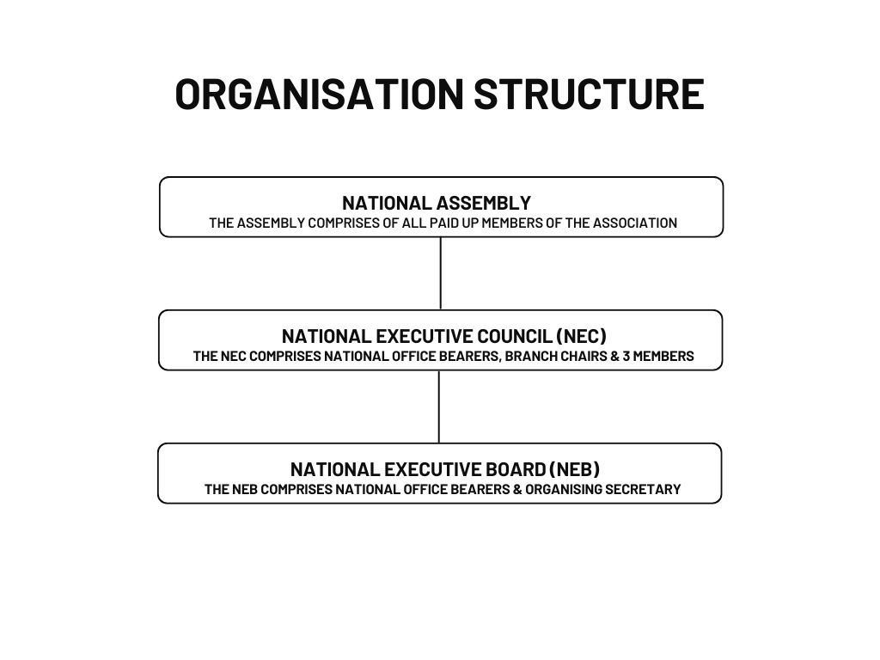

**COMMITTEES:**

**KNAPO Ethics Committee**

The KNAPO Ethics Committee is responsible for receiving and addressing complaints against members, as well as recognizing and rewarding professional conduct.

**National Training Committee**

A National Training Committee assess training needs submitted to the National Secretariat and determine which members qualify for available training opportunities.

**Investments Committee**

This committee manages assets and investments held in the name of KNAPO. All members of the committee must be fully paid-up members of KNAPO.

**3. MEMBERSHIP**

BENEFITS:

Joining the Kenya National Association of Probation Officers will offer you several key benefits, both professionally and personally. Here are some of the main advantages:

1. Professional Development

* You will gain access to specialized training sessions, workshops, and seminars that help enhance your knowledge and skills in probation work.
* You will get certificates that will help you advance your career and meet professional standards.
* Receive special access to conferences, networking events, and other industry gatherings that provide valuable learning and exposure.
* You will stay up to date with the latest research, reports, and publications related to probation work released by the association.

2. Support and Welfare

* You will become part of a supportive community of professionals who share similar challenges and goals. This can foster a sense of belonging and reduce feelings of isolation in your work.
* Given the nature of probation work, the association often provides a space for members to share experiences, seek advice, and receive emotional support from peers.

3. Networking Opportunities

* You will have an opportunity to connect with fellow Probation Officers and other professionals in related fields; and share best practices and advice.
* You will build relationships with organizations, both local and international, that support probation work, leading to potential partnerships or collaboration on projects.

4. Advocacy and Representation

* You will be part of an organized body that advocates for better working conditions, policies, and resources for Probation Officers
* You will get professional support and assistance in navigating ethical challenges, ensuring that you are aligned with professional standards and regulations

Joining the Kenya National Association of Probation Officers of Probation Officers strengthens both your individual practice and the broader probation profession, allowing for continual growth and positive change in the field.

**MEMBERSHIP TYPES:**

KNAPO offers two types of memberships: **Individual Membership** and **Corporate Membership**.

**I. Individual Membership**

1. **Serving Probation Officers**  
   Serving Probation Officers are eligible for individual membership, which involves a monthly or annual contribution.
2. **Students**  
   Students pursuing studies in fields related to probation or criminal justice can join at a reduced rate.
3. **Honorary/Retired Members**  
   This membership category is for individuals who have made distinguished contributions to probation practice or offender rehabilitation, such as retired professionals or those honored for their service. They receive special recognition for their contributions.

**II. Corporate Membership**

1. **Local (Kenyan) Corporate Members**  
   Kenyan organizations, including government bodies, non-profits, or businesses with an interest in probation and rehabilitation, can become corporate members.
2. **Donor Agencies in Kenya**  
   Donor organizations based in Kenya can also join as corporate members, showing their support for probation services and offender rehabilitation.
3. **Regional (East African) Corporate Members**  
   Organizations from other East African countries can join as regional corporate members to strengthen collaboration in probation and rehabilitation practices across the region.
4. **International Corporate Members**  
   International organizations, including NGOs and other entities supporting global probation efforts, can join as international corporate members, promoting cross-border cooperation.

Each membership category offers opportunities for networking, collaboration, and contributing to the advancement of probation services and rehabilitation programs.

**JOINING INSTRUCTIONS:**

**Joining Instructions**

To join KNAPO, follow these steps based on your membership type:

**I. Individual Membership**

1. **Complete the Membership Form**  
   Fill out the membership form available on the KNAPO website or at the office.
2. **Submit the Required Documents**  
   Depending on your membership category (Serving Probation Officer, Student, or Honorary/Retired Member), submit any necessary documents, such as proof of employment or student status.
3. **Make the Required Contributions**  
   After registration, make the monthly or annual contribution as specified for your category:
   * **Serving Probation Officers**: Monthly contribution of Kshs. 400 or an annual contribution of Kshs. 4,800.
   * **Students**: Monthly contribution of Kshs. 100 or an annual contribution of Kshs. 1,200.
   * **Honorary/Retired Members**: Monthly contribution of Kshs. 100 or an annual contribution of Kshs. 1,200.

**II. Corporate Membership**

1. **Complete the Corporate Membership Form**  
   Fill out the corporate membership application form available on the KNAPO website or at the office.
2. **Submit Relevant Documents**  
   Provide necessary documentation for your organization, such as business registration certificates or proof of donor agency status.
3. **Make the Required Payments**  
   Depending on your organization's category, submit the required registration and annual subscription fees:
   * **Local (Kenyan) Corporate Members**: Registration fee of Kshs. 5,000, with an annual fee of Kshs. 10,000.
   * **Donor Agencies in Kenya**: No registration fee, but an annual subscription fee of USD $3,000.
   * **Regional (East African) Members**: Registration fee of USD $100, with an annual fee of USD $250.
   * **International Members**: Registration fee of USD $200, with an annual fee of USD $500.

Once your membership form is completed and payment is processed, you will be officially registered as a KNAPO member and can begin participating in all associated activities and benefits.

**4. EVENTS**

**CALENDAR**

There are no upcoming events.

**5. RESOURCES**

**DOWNLOADS**:

* Membership Forms (see attached)
* Research papers
* Newsletters
* Reports
* Brochures (see attached)

**USEFUL LINKS:**

[www.probation.go.ke](http://www.probation.go.ke)

**6. ADVOCACY AND INITIATIVES**

**CURRENT PROJECTS:**

**Ongoing Initiatives and Advocacy Efforts**

KNAPO is actively engaged in several initiatives aimed at advancing the welfare of its members and improving probation practices in Kenya. A key aspect of this work is representing members on welfare matters. The association continuously advocates for the professional, personal, and social welfare of Probation Officers, ensuring their needs are met and their interests are safeguarded. This includes addressing issues related to working conditions, career development, and benefits, providing a supportive platform for members to voice concerns and seek resolutions.

Additionally, KNAPO plays a crucial role in contributing to the development of national policies, particularly the National Correctional Policy. The association will provide expert input, offering recommendations and suggestions that reflect the realities of probation practice. By participating in policy discussions, KNAPO ensures that the perspectives and needs of Probation Officers are considered in shaping laws and strategies related to corrections, rehabilitation, and crime prevention. These ongoing advocacy efforts aim to create a more effective, supportive, and just system for both Probation Officers and the individuals under their care.

**POLICY POSITIONS:**

KNAPO holds firm policy positions on several critical issues affecting the probation profession, aimed at improving the effectiveness of Probation Officers and the broader criminal justice system. These positions reflect the association's commitment to upholding professional standards, protecting the welfare of its members, and contributing to the effective rehabilitation of offenders. Some of the key policy stances include:

1. **Advocacy for Improved Working Conditions**

KNAPO advocates for better working conditions for Probation Officers, including adequate compensation, safety, and support. This includes ensuring manageable caseloads, access to professional development, and resources needed to carry out their duties effectively.

1. **Strengthening Probation Practices and Resources**

The association advocates for increased investment in probation services, including more robust training programs, modern tools, and resources that enhance the delivery of rehabilitation programs. This ensures that Probation Officers are equipped to manage offenders successfully and contribute to crime prevention efforts.

1. **Support for Non-Custodial Sentencing and Rehabilitation**

KNAPO strongly supports the use of non-custodial sentencing options, emphasizing rehabilitation over incarceration. The association believes that probation and alternative sentencing can reduce prison overcrowding, promote offender reintegration, and lower recidivism rates.

1. **Advocacy for Clearer Legal Frameworks**

KNAPO calls for the establishment of clear and supportive legal frameworks that govern the probation profession. This includes policies that ensure the safety and rights of Probation Officers, the fairness of the probation process, and proper oversight of probation practices.

1. **Improvement of Member Welfare**

The association is dedicated to advocating for better welfare policies for its members, including health benefits, retirement plans, and a fair grievance redressal system. KNAPO ensures that the needs of its members, both professionally and personally, are addressed through its advocacy efforts.

1. **Collaboration with International Bodies**

KNAPO supports stronger collaboration with international organizations and networks, adopting best practices from around the world. The association believes in global cooperation to improve probation practices and ensure alignment with international standards in offender rehabilitation and crime prevention.

These policy positions guide KNAPO's actions and advocacy, aiming to enhance the probation profession, the welfare of its members, and the effectiveness of the criminal justice system in Kenya.

**7. Contact Us**

The National Secretary,

Kenya National Association of Probation Officers,

P. O. Box 6104-00100,

Nairobi, KENYA.

Phone number: +254-702-850-673

Email: [knapo.org@gmail.com](mailto:knapo.org@gmail.com)

X : @KNAPO_

Facebook: knapokenya

**8. Member Login Area**

- Member Directory: Access to a directory of current association members. - Exclusive Content: Resources or content available only to members i.e. Constitution, Governance Manual, Code of Conduct, (Haven’t done this section, don’t know how to go about it.)

**9. Footer**

@2025, Kenya National Association of Probation Officers. All rights reserved.